Week 4:

Plan:

Program design：---- done

* Determine program features ---- done
* User interface Wireframe ---- done
* Sequence Diagram ---- done
* Main page flowchart ---- done

**Sequence Diagram**: Represent the dynamic flow of the program

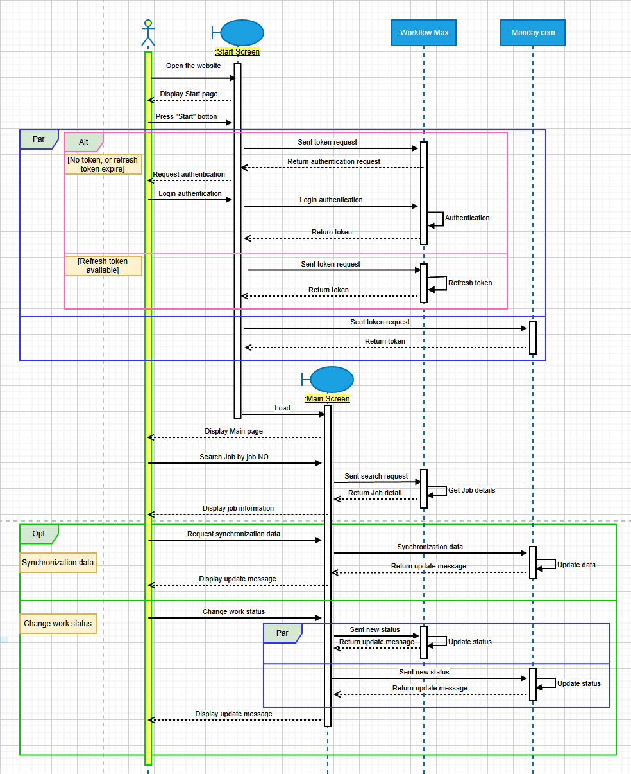

**User interface Wireframe:**

**Start page:**

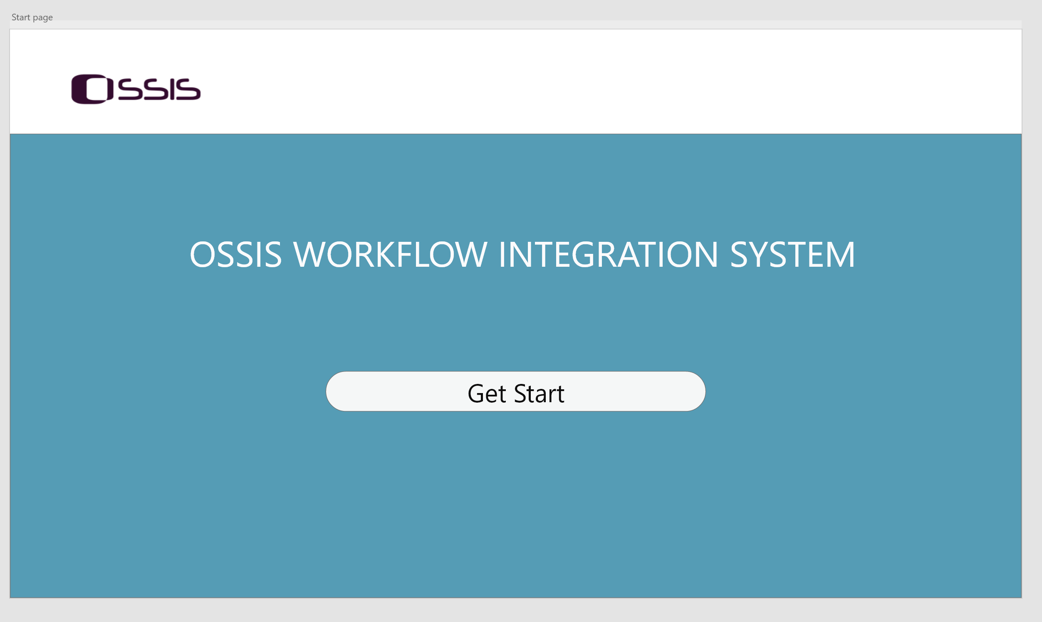

**Main page:**

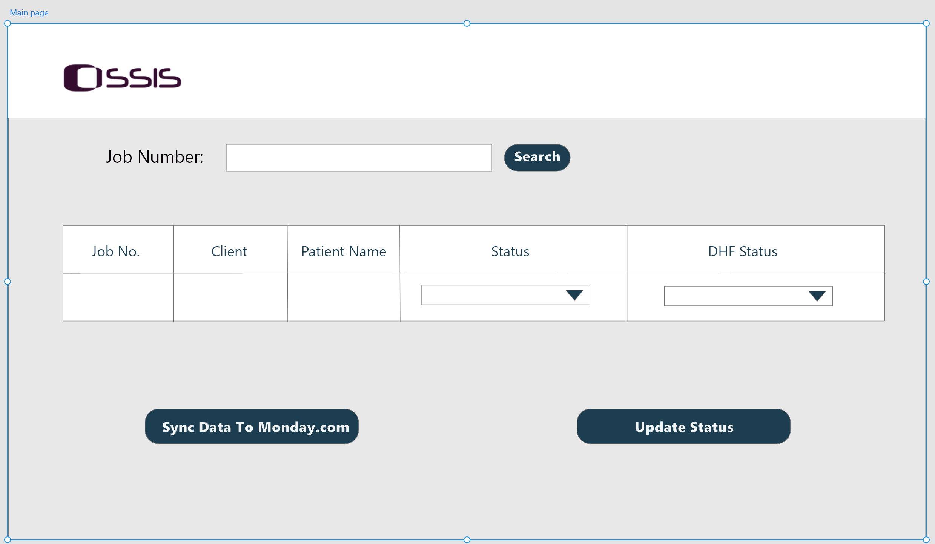

**Job detail page:**

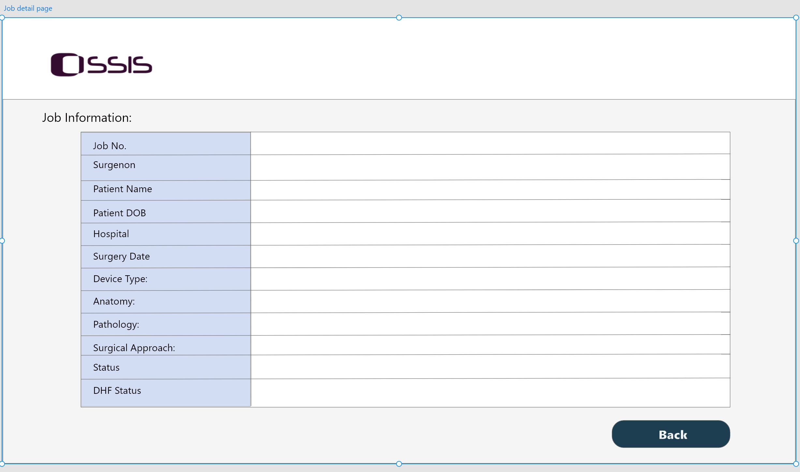

**Flowchart for main page:**

**Front-end development preparation**

VUE：

Install Vue cli and create a project.

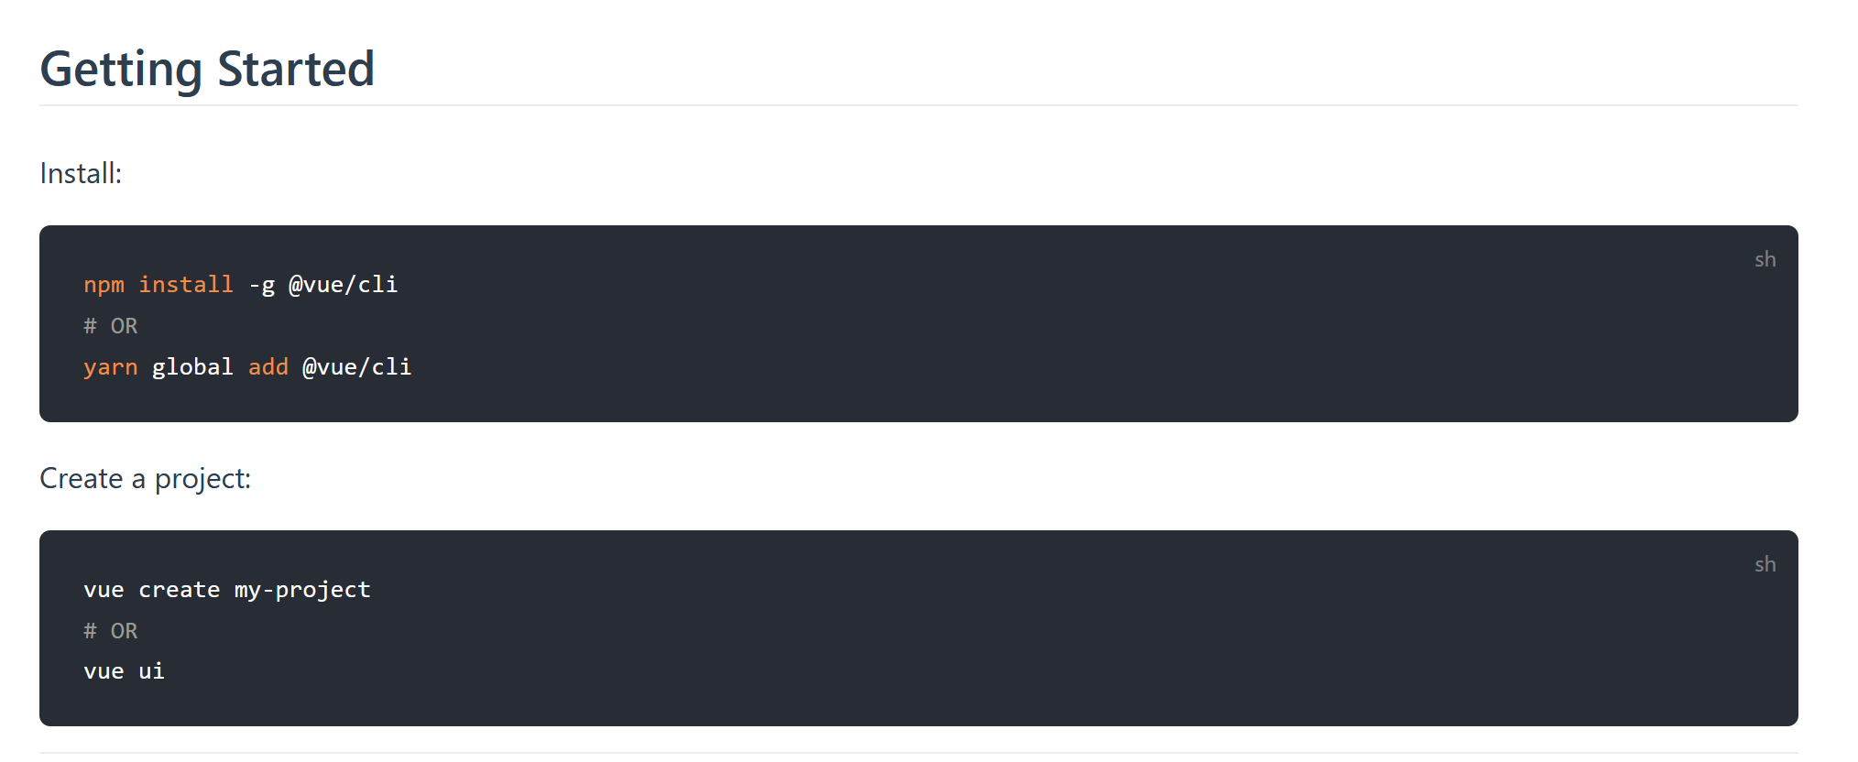

Start server for Vue:

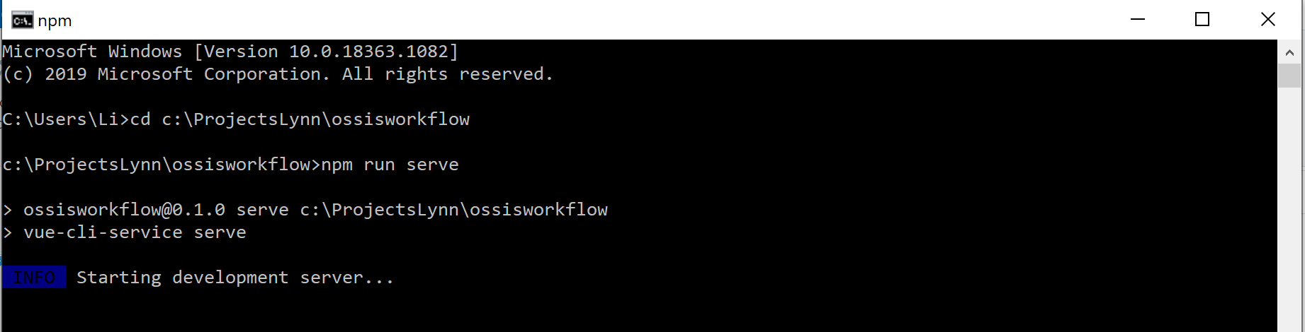

Install Bootstrap:

